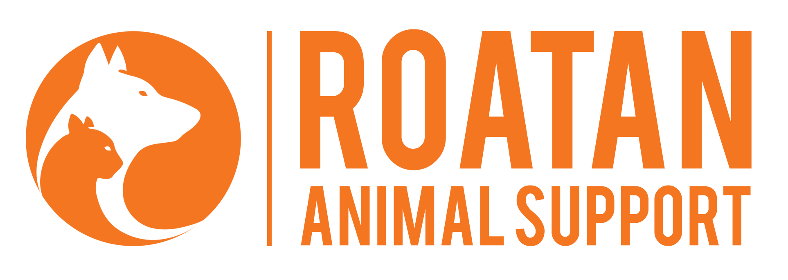

November 2019 Financial Statement

ITEM | TOTAL
Total Cash Donations & Fundraising | $1076.60
Total Paypal Donations | $9.41
Expenses (ingredients for treats, raffle basket fillers, polaroid camera, sign hangers) | -$332.85
Expenses (Veterinary & Animal Care) | -$301.22
Total Donations | $1,086.01
Beginning balance August 1, 2019 | $1,060.52
Total Cash

$1,512.46

